SMART ENERGY-CONSUMPTION ANALYTICS SYSTEM
PROJECT REPORT — Hadoop HDFS, MapReduce and YARN
COURSECODE&NAME: CSA1504-CLOUD COMPUTING AND BIG DATA ANALYTICS
DEPARTMENT OF COMPUTER SCIENCE AND ENGINEERING
ASSIGNMENT REPORT

STUDENT NAME:S.Aswini
REG NO:192511077
DATE OF SUBMISSION:02/09/2026

1. Problem Definition
The Smart Energy-Consumption Analytics System is designed to process large-scale energy records generated by smart meters, IoT sensors, residential/commercial buildings, industrial systems, renewable-energy installations and connected appliances. HDFS provides distributed storage, MapReduce performs parallel analytics, and YARN manages cluster resources and job execution.
The system identifies total and average consumption, peak-demand hours, high-consumption consumers/buildings, appliance/category usage, tariff-period differences, daily/monthly trends, abnormal consumption and renewable-energy generation.

2. Objectives
- Store large energy datasets in HDFS.
- Process records in parallel using MapReduce.
- Use YARN for resource management and job scheduling.
- Identify consumption patterns and peak-demand periods.
- Find high-consumption locations and categories.
- Compare consumer types and tariff periods.
- Generate results that support energy-efficiency and sustainable management.

3. Dataset Description
Field | Description | Sample
Meter_ID | Unique smart-meter identifier | M001
Consumer_ID | Unique consumer/building identifier | C101
Date | Date of observation | 2026-09-01
Time | Time of observation | 18:00
Location_ID | Building/area/feeder identifier | L01
Consumer_Type | Residential, Commercial, Industrial, etc. | Residential
Appliance_Category | Lighting, HVAC, Refrigeration, Computing, etc. | HVAC
Energy_Consumption | Energy consumed in kWh | 4.50
Voltage | Measured voltage | 230 V
Current | Measured current | 8.20 A
Power_Factor | Power factor value | 0.92
Tariff_Period | Peak, Off-Peak, Normal, etc. | Peak
Renewable_Generation | Solar/wind energy generated in kWh | 1.20

4. System Architecture
Energy Data Sources → HDFS → YARN → MapReduce → Mapper → Shuffle & Sort → Reducer → Energy Analytics → Reports/Results → Smart Energy Management
HDFS: distributed storage | YARN: resource management | MapReduce: parallel data processing

5. HDFS Implementation – Pseudocode
BEGIN
START Hadoop/HDFS
CREATE HDFS directory for energy data
UPLOAD input CSV dataset to HDFS
LIST HDFS directory
VERIFY uploaded files
SUBMIT MapReduce job using HDFS input
STORE processed output in HDFS
RETRIEVE output for analysis
END

6. General MapReduce – Pseudocode
BEGIN
READ energy record from HDFS
MAPPER:
Parse record
Extract required fields
EMIT intermediate KEY-VALUE pair
SHUFFLE AND SORT:
Group records by key
REDUCER:
Receive key and values
Aggregate/calculate result
EMIT final result
SAVE final output to HDFS
END

6.1 Total Energy Consumption by Location
MAPPER(record)
location ← record.Location_ID
energy ← record.Energy_Consumption
EMIT(location, energy)
REDUCER(location, values)
total ← 0
FOR each energy IN values
total ← total + energy
EMIT(location, total)

6.2 Average Energy Consumption
MAPPER(record)
location ← record.Location_ID
energy ← record.Energy_Consumption
EMIT(location, (energy, 1))
REDUCER(location, values)
total ← 0
count ← 0
FOR each (energy, one) IN values
total ← total + energy
count ← count + one
EMIT(location, total / count)

6.3 Peak Energy-Consumption Hour
MAPPER(record)
hour ← EXTRACT_HOUR(record.Time)
energy ← record.Energy_Consumption
EMIT(hour, energy)
REDUCER(hour, values)
total ← SUM(values)
EMIT(hour, total)
FINAL: Select the hour having MAX(total).

6.4 Consumer-Type Analysis
MAPPER(record)
type ← record.Consumer_Type
energy ← record.Energy_Consumption
EMIT(type, energy)
REDUCER(type, values)
EMIT(type, SUM(values))
COMPARE Residential, Commercial and Industrial totals.

6.5 Appliance / Category Analysis
MAPPER(record)
category ← record.Appliance_Category
energy ← record.Energy_Consumption
EMIT(category, energy)
REDUCER(category, values)
EMIT(category, SUM(values))

6.6 Tariff-Period Analysis
MAPPER(record)
tariff ← record.Tariff_Period
energy ← record.Energy_Consumption
EMIT(tariff, energy)
REDUCER(tariff, values)
EMIT(tariff, SUM(values))
COMPARE Peak, Normal and Off-Peak totals.

6.7 High-Consumption Locations
MAPPER(record)
location ← record.Location_ID
energy ← record.Energy_Consumption
EMIT(location, energy)
REDUCER(location, values)
EMIT(location, SUM(values))
FINAL: Sort locations in descending order and select the top locations.

6.8 Renewable-Energy Analysis
MAPPER(record)
location ← record.Location_ID
EMIT(location, (record.Energy_Consumption,
record.Renewable_Generation))
REDUCER(location, values)
total_consumption ← SUM(consumption values)
total_renewable ← SUM(renewable values)
EMIT(location, (total_consumption, total_renewable))

7. YARN Execution – Pseudocode
BEGIN
CHECK YARN cluster status
SUBMIT MapReduce application
YARN allocates resources
START Application Master
RUN Mapper tasks
PERFORM Shuffle and Sort
RUN Reducer tasks
MONITOR job status
RECORD execution time and CPU/memory utilization
STORE final output in HDFS
END

8. Output Images / Result Visualization
The following are illustrative sample outputs for report presentation. For the final implementation report, replace or supplement them with screenshots/charts generated from the actual Hadoop MapReduce output.

8.1 Location-wise Consumption
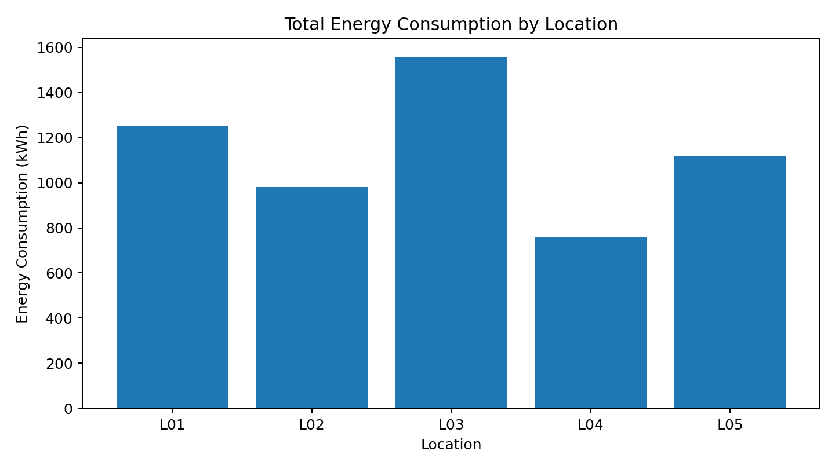
Figure 1. Total energy consumption by location.

8.2 Peak-Hour Analysis
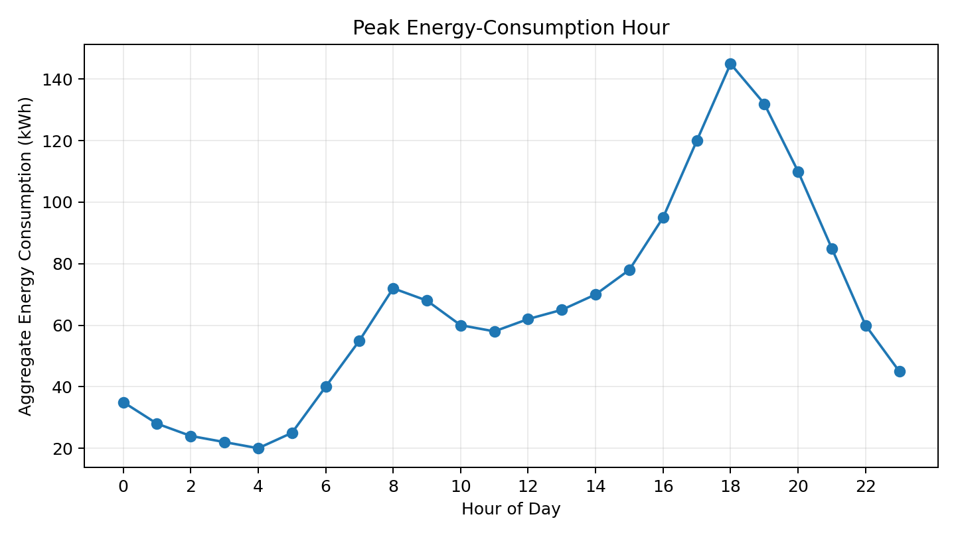
Figure 2. Aggregate energy consumption by hour.

8.3 Appliance / Category Distribution
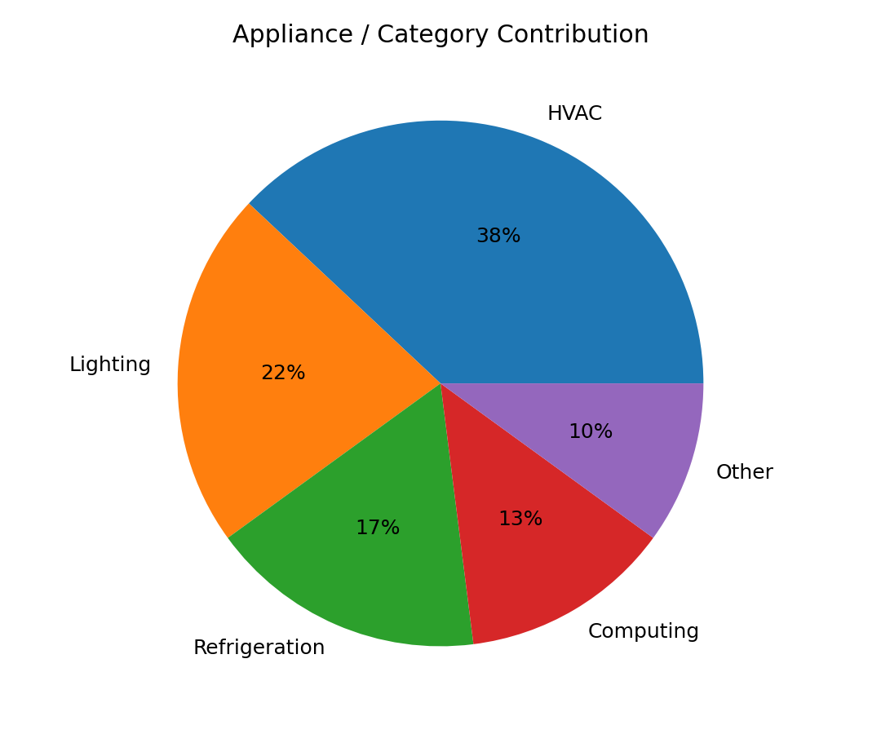
Figure 3. Appliance/category contribution.

8.4 Tariff-Period Comparison
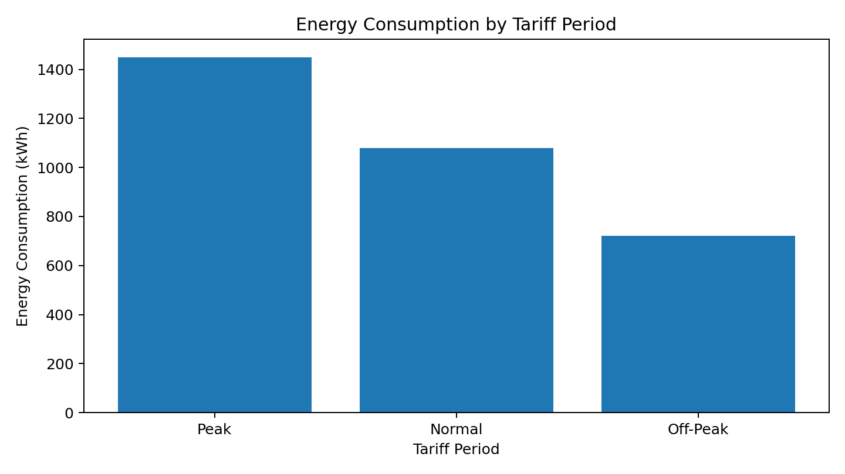
Figure 4. Energy consumption across tariff periods.

9. Sample Output
LOCATION-WISE OUTPUT
L01 1250 kWh
L02 980 kWh
L03 1560 kWh
L04 760 kWh
L05 1120 kWh
PEAK-HOUR OUTPUT
18:00 → 145 kWh
TARIFF OUTPUT
Peak → 1450 kWh
Normal → 1080 kWh
Off-Peak → 720 kWh

10. Result Interpretation
- L03 has the highest illustrative total consumption.
- 18:00 is the illustrative peak-demand hour.
- HVAC is the largest illustrative appliance/category contributor.
- Peak tariff shows the highest illustrative consumption.
- High-consumption locations can be targeted for energy audits and efficiency improvements.
- Tariff and category analysis can support demand management.
- Renewable generation can be compared with consumption to assess renewable contribution.

11. Performance and Scalability Analysis
- HDFS distributes large datasets across storage nodes.
- MapReduce enables parallel processing of large workloads.
- YARN manages resources and schedules applications.
- Scalability should be evaluated using dataset size, execution time, mapper/reducer count, CPU, memory and job status.
- HDFS replication improves availability and fault tolerance.

12. SDG Mapping
- SDG 7 – Affordable and Clean Energy: efficient energy utilization and renewable-energy analysis.
- SDG 9 – Industry, Innovation and Infrastructure: Big Data technology for energy infrastructure.
- SDG 11 – Sustainable Cities and Communities: data-driven energy management.
- SDG 12 – Responsible Consumption and Production: identification of excessive/inefficient energy use.
- SDG 13 – Climate Action: improved energy efficiency and renewable-energy utilization.

13. Conclusion
The Smart Energy-Consumption Analytics System combines HDFS, MapReduce and YARN to process large-scale energy data. It provides analytics for consumption, peak periods, high-consumption locations, appliance categories, tariff periods and renewable generation. These insights can support scalable, data-driven and sustainable energy management.

15.1 HDFS Dataset Upload and Verification
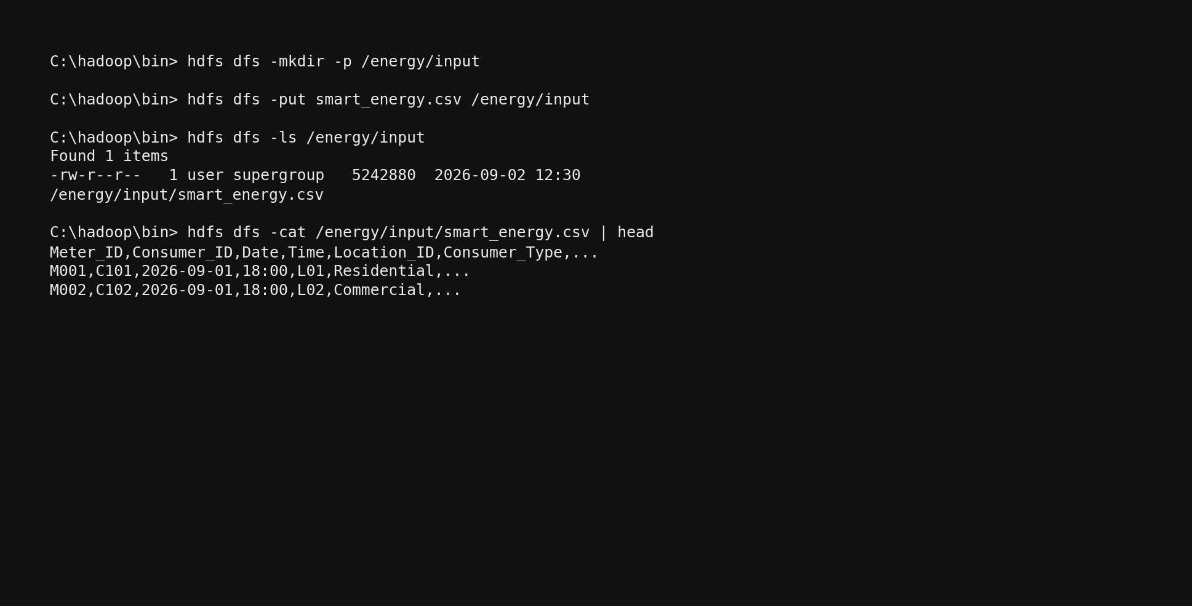
Figure 15.1 – HDFS directory creation, CSV upload and file verification.

15.2 MapReduce Job Execution
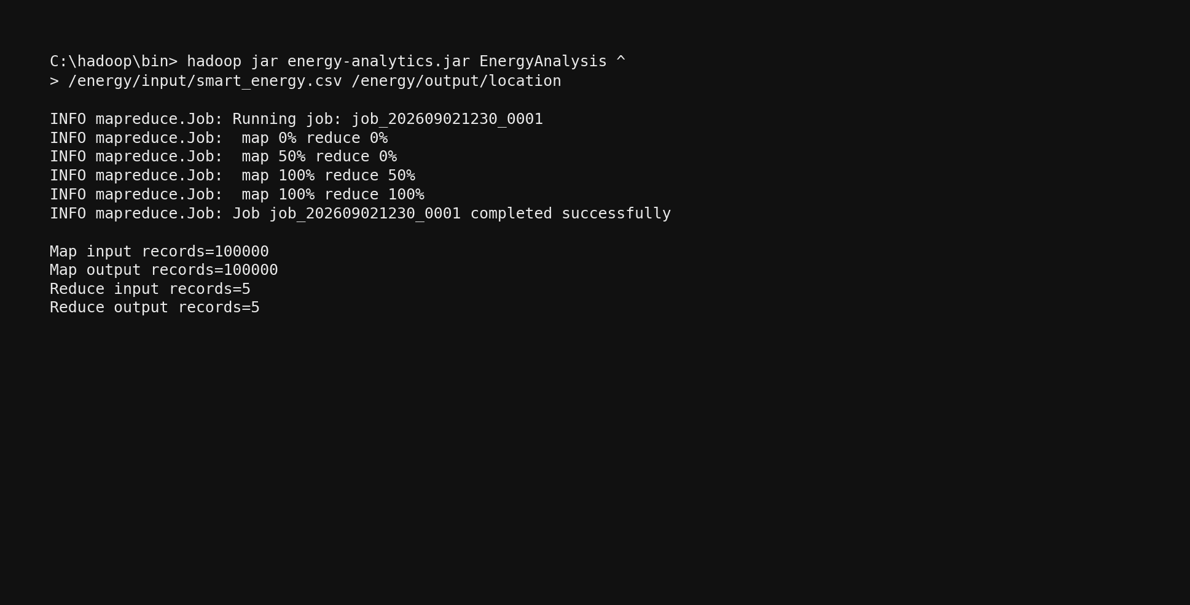
Figure 15.2 – MapReduce mapper/reducer job progress and completion.

15.3 YARN Application Status
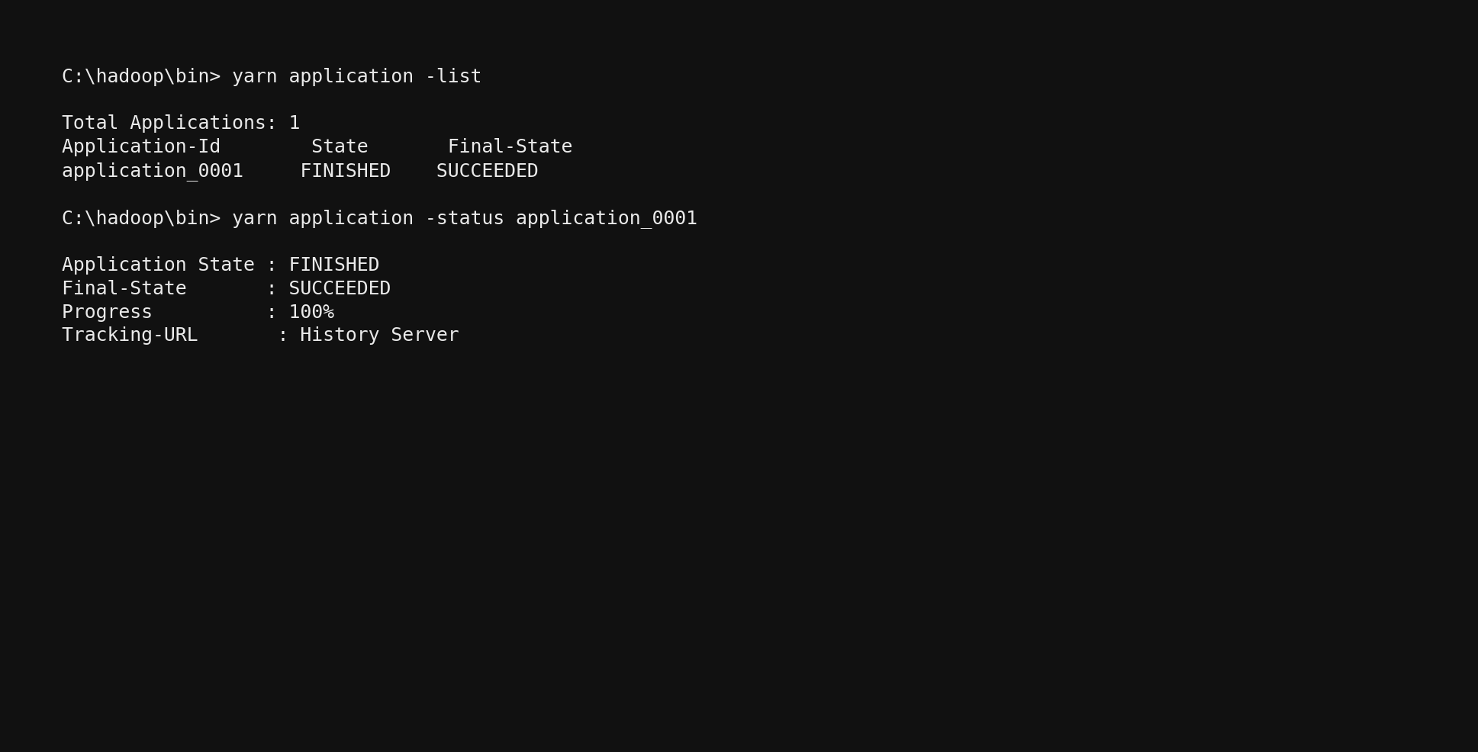
Figure 15.3 – YARN application status and successful completion.

15.4 HDFS Reducer Output
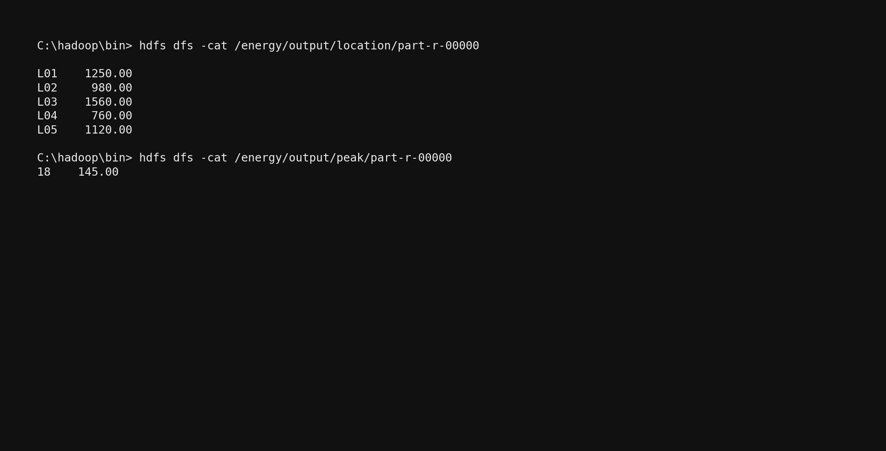
Figure 15.4 – Reducer output retrieved from HDFS.

16. Pseudocode Formatting Standard
All pseudocode in this report uses a monospaced Consolas font so that indentation, KEY-VALUE pairs, Mapper/Reducer blocks and algorithm steps remain aligned and readable.
Recommended structure:
MAPPER(key, record)
READ record
EXTRACT required field
EMIT(key, value)
SHUFFLE AND SORT
GROUP values by key
REDUCER(key, values)
INITIALIZE aggregate
FOR each value IN values
UPDATE aggregate
EMIT(key, aggregate)

17. YARN Resource Management, Performance and Scalability Analysis
The assignment requires demonstration of cluster status, MapReduce submission through YARN, application execution, resource allocation, job status, CPU/memory/resource utilization, and suitable command-line/interface screenshots. fileciteturn1file0L101-L107
Suggested evidence to record during the actual run:
- YARN cluster/node status before job submission.
- Application ID, application state, start time and finish time.
- Map and reduce task counts.
- Allocated containers and memory.
- CPU/vCore allocation and utilization, where available.
- Job completion status and execution time.
- HDFS input and output locations.
- Output file names such as part-r-00000.
Scalability analysis:
- As input records increase, HDFS can distribute large files across blocks and nodes.
- Map tasks can process partitions in parallel, reducing dependence on a single machine.
- YARN allocates cluster resources and schedules jobs.
- Replication in HDFS improves data availability and fault tolerance.
- Additional worker capacity can support larger workloads, subject to cluster configuration.
- Performance should be evaluated using actual execution time and resource statistics from the student's cluster rather than invented benchmark values.

19. Energy Analytics and Result Interpretation
The assignment expects interpretation of the highest-consuming location/consumer, peak period, average consumption, high-consumption areas, appliance/category distribution, tariff differences, and possible efficiency improvements. fileciteturn1file0L371-L375
- Highest-consuming location/consumer: select the maximum total from the location/consumer MapReduce output.
- Peak energy period: select the hour with the maximum aggregate consumption.
- Average consumption: compare location or consumer-category averages.
- High-consumption areas: rank locations and investigate the top entries.
- Appliance/category distribution: identify categories contributing the largest share.
- Tariff-period differences: compare Peak, Off-Peak and Normal totals.
- Renewable contribution: compare renewable generation with consumption.
- Daily/monthly trends: identify periods of rising or falling demand.
- Abnormal locations: investigate locations flagged by the high-consumption threshold.

20. SDG Mapping and Sustainability Analysis
The assignment explicitly maps the work to SDG 7, SDG 9, SDG 11, SDG 12 and SDG 13. fileciteturn1file0L22-L28
SDG | Connection to the System | Expected Contribution
SDG 7 – Affordable and Clean Energy | Energy consumption and renewable-generation analytics | Supports efficient use of energy and greater visibility of clean-energy contribution.
SDG 9 – Industry, Innovation and Infrastructure | Hadoop distributed processing infrastructure | Demonstrates scalable digital infrastructure for large energy datasets.
SDG 11 – Sustainable Cities and Communities | Building/location-level analytics | Supports data-driven planning for efficient energy use in communities.
SDG 12 – Responsible Consumption and Production | High-consumption and appliance/category analysis | Helps identify inefficient usage and opportunities to reduce unnecessary consumption.
SDG 13 – Climate Action | Renewable analysis and energy-efficiency insights | Supports actions that can reduce energy waste and associated environmental impact.

21. Conclusion and Reflection
Conclusion: The Smart Energy-Consumption Analytics System demonstrates how HDFS, MapReduce and YARN can be combined to process and analyse large-scale smart-energy data. The workflow stores the dataset in distributed storage, executes parallel analytics through Mapper and Reducer stages, and uses YARN for resource management and job execution. The resulting outputs support identification of consumption patterns, peak periods, high-consumption locations, category usage, tariff differences, renewable contribution and potential efficiency opportunities.
References
- Apache Hadoop Documentation – HDFS User Guide
Apache Hadoop HDFS User Guide
Used for HDFS distributed storage, NameNode, DataNode and Hadoop storage concepts.
- Apache Hadoop Documentation – MapReduce Tutorial
Apache Hadoop MapReduce Tutorial
Used for Mapper, Reducer, parallel processing and large-scale data processing concepts.
- Apache Hadoop Documentation – YARN
Apache Hadoop YARN Documentation
Used for ResourceManager, NodeManager, ApplicationMaster, resource allocation and job scheduling.
- Apache Hadoop – Single Node Cluster Setup
Apache Hadoop Single Node Setup
Used for Hadoop/HDFS setup, MapReduce execution and YARN configuration.

